
Lesson Plan Prepared for
ARRL Education & Technology Program
Author(s): Nathan McCray | Date: 06/24/2013
Title of Lesson: Kepler’s 3rd Law (Law of planetary motion) | Grade Level: 8 – 12+

Core Components

Subject, Content Area or Topic:

Physics, Electronics, Science, Math

National/State Standards: (Assign as needed based on your state standards)

Common Core Standards: (Assign as needed based on your state requirements)

http://www.corestandards.org/

Vocabulary: (Teacher add as needed based on your curriculum and learning requirements)

Learning Objectives (What will the students learn and/or demonstrate?)

The objective of this activity is for the students to explore Kepler’s 3rd Law

Materials/Resources

Safety (if applicable) NA

Prerequisite Understanding:
Keplers 1st and 2nd law and the law of gravitation. (Newton first formulated the law of gravitation from Kepler's 3rd law)
This is a simple concept to say, but the mathematics can be challenging. Be prepared.

Process Components
Anticipatory Set:
(“The Hook” -- something to excite the student about the subject matter)

Sometimes we think that scientists like Kepler came up with their hypotheses in a few hour or days. What most of us that have studied any sort of natural phenomenon know is it can take years of collecting and researching data to prove or disprove a theory. So, how difficult was it for Kepler to prove his laws? According to Robert Wilson, “It took Kepler eight years and nearly a thousand pages of closely written calculations before he cracked the problem and discovered his first two laws of planetary motion. It would take another nine years to prove his third law!.”

Can you imagine spending eight years on a geometry problem you are not even sure can be solved, then another nine years to finish the task?

Instructional Input or Procedure (Input, modeling, and checking for understanding)

Introduce the concept to the class and go over a few problems.

Kepler's 3rd Law: P² = a³
* This equation only works for objects which are orbiting the sun.*

Kepler's 3rd law is a mathematical formula. It means that if you know the period of a planet's orbit (P = how long it takes the planet to go around the Sun), then you can determine that planet's distance from the Sun (a = the semi major axis of the planet's orbit).
It also tells us that planets that are far away from the Sun have longer periods than those close to Kepler's third law deals with the length of time a planet takes to orbit the Sun, called the period of revolution. The law states that the square of the period of revolution is proportional to the cube of the planet's average distance to the sun:
P²=a³
Because of the way a planet moves along its orbit, its average distance from the Sun is half of the long diameter of the elliptical orbit (the semi major axis.) The period, P, is measured in years and the semi major axis, a, is measured in astronomical units (AU), the average distance from the Earth to the Sun.
A Little Math
Kepler's third law is a mathematical relation between a planet's period and its average distance. With a little simple algebra we can determine one of the values if we are given the other. First of all it helps to rearrange the relationship slightly and apply a little cleverness:
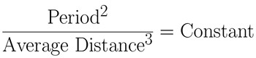
Kepler's third law can be rearranged and turned in to “an equality” as is shown on the left. The Constant is just a number. However, it is important to know that this Constant is the same for anything orbiting the Sun. The value of this Constant depends on the units you use to measure the Period and Average Distance. Here is where the clever part come in:
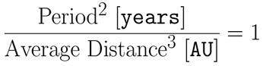
If you measure the Period in [years] and the Average Distance in astronomical units [AU] [an astronomical unit is defined as the average distance between the Earth and the Sun] then the Constant equals 1. Why is this? Well the Earth has a period of 1 year and an average distance if 1 AU. Stick these numbers into the equation above and the Constant equals 1. Now, since this constant is the same for everything orbiting the Sun, as long as you measure the period in years and the average distance in AUs then the Constant is always 1.
An Example
Determine the period of an object that orbits the Sun at an average distance of 4 AU.
Plug the average distance into the equation above, do a little algebra:
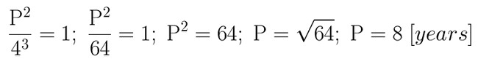
And voila! An object with an average distance of 4 AU takes 8 years to go around the Sun. Easy as can be. Of course not all (or many) problems have such nice integer answers, but that is why calculators were invented.

Another Example:

1. Kepler's third law says that P²=a³is the same for all objects orbiting the Sun. Vesta is a minor planet (asteroid) that takes 3.63 years to orbit the Sun. Calculate the average Sun-Vesta distance.

Solution: 1 = P²=a³= a³/(3.63) ²= a³/(13.18) ⇒ a³= 13.18 ⇒2.36 AU

Guided Practice
Kepler’s 3rd Law Activity

As you have seen, Kepler’s 3rd law states that the semi-major axis of a planet’s orbit (average distance to the sun in A. U.’s) is related to the planet’s orbit period (in Earth-years) by the equation:
p² = a³

Where p = orbital period in Earth years and a = distance from sun in A.U.’s.

In other words, p²/a³ = 1 if Kepler’s 3rd law is to hold true for all planets.

Mathematically prove the accuracy of this law by computing and recording p², a³, and the value for p²/a³ (round answers to .01) in the following table:

planet | orbital period | semi-major axis | p² | a³ | p²/a³
 | (years) | (A.U.'s)
Mercury | 0.241 | 5.79
Venus | 0.615 | 0.723
Earth | 1 | 1 |  |  | 1
Mars | 1.881 | 1.524 | 3.538161 | 3.539 | .9995
Jupiter | 11.86 | 5.203 | 140.6596 | 140.851 | .9986
Saturn | 29.46 | 9.539
Uranus | 84.01 | 19.19
Neptune | 164.8 | 30.06
Pluto | 248.6 | 39.53

Independent Practice

How far does Halley's comet go?
Its period is about 75 years, and 75² = 5625. Take the cube root: A = 17.784 AU. That, however is the SEMI major axis. The length of the entire orbital ellipse is 2A = 35.57 AU. Perihelion is inside the Earth's orbit, less than 1 AU from the Sun, so aphelion is about 35 AU from the Sun--as the table shows, somewhere between Neptune's orbit and Pluto's
QUESTION:
What if there were a planet that went around the sun twice as fast as that of earth. Compute the orbital size as compared to earth.
ANSWER:
You can do this using Kepler's third law, the square of the period is proportional to cube of the radius. T_{earth}=1 year, T_{new}=½ year, so (T_{new}/T_{earth})²=(R_{new}/R_{earth})³ =(½/1)²=¼, so R_{new}=(³√¼)R_{earth}=0.63R_{earth}.

Assessment/Closure

Assessment (Pre, post etc…)

As teacher sees fit.
Enrichment: Investigate Newtons law of universal gravitation and the inverse square law.
Resources/References

http://www.youtube.com/watch?v=DJfu9R-4new

*Every lesson is different so you may not have to fill in all areas.

Notes:
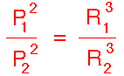
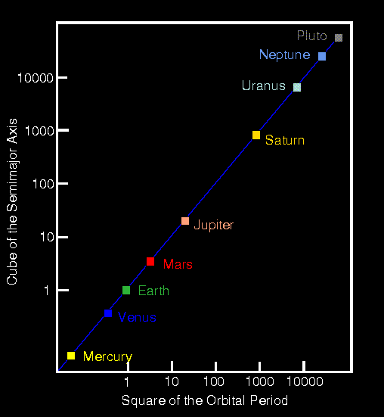

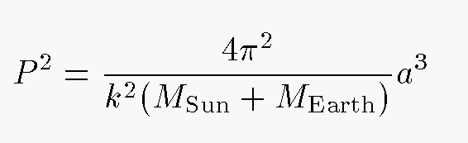

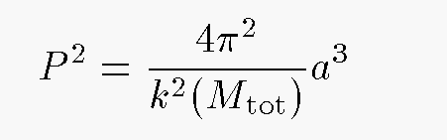
The constant k in the equations above is known as the Gaussian gravitational constant. If we set up a system of units with
- period P in days
- semimajor axis a in AU
- mass Mtot in solar masses
Then we can determine k very precisely and very simply: just count the days in a year! Then we can simply turn Kepler's Third Law around to solve for the value of k:

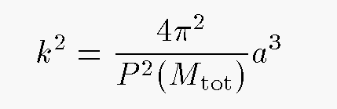

Exercise: What is the value of the Gaussian gravitational constant k?
The key point here is that the only measured quantity we need to find k is time: the period of the Earth's orbit around the Sun. Now, it's not quite so easy as it sounds, but it can be done without too much trouble. Moreover, because we can average over many, many, many years, we can determine the length of the year very accurately -- to many significant figures. Therefore, we can also determine the value of k to many significant figures. If all we want to do is calculate the orbits of objects around the Sun, then k is all we need; and with a very accurate value of k, we can calculate very accurate planetary orbits.
For example, it was this constant k that Adams and Leverrier used in their computations of the as-yet-unknown planet VIII, aka Neptune.
At this point, you may be thinking, "Hey, wait a minute -- isn't that constant k just another way of writing the Newtonian Constant of Universal Gravitation, G?" Well, the answer is yes, and no:
- Yes, the two constants are closely related
- No, they don't stand for EXACTLY the same thing
The Gaussian constant, k, is defined in terms of the Earth's orbit around the Sun. The Newtonian constant, G, is defined in terms of the force between two two masses separated by some fixed distance. In order to measure k, all you need to do is count days; in order to measure G, you need to know very precisely the masses, separation, and forces between test objects in a laboratory. The Gaussian constant is obviously much easier to determine. Look at a sample pair of values from recent compilations:

k = 0.01720209895

-11
G = 6.6742 x 10

