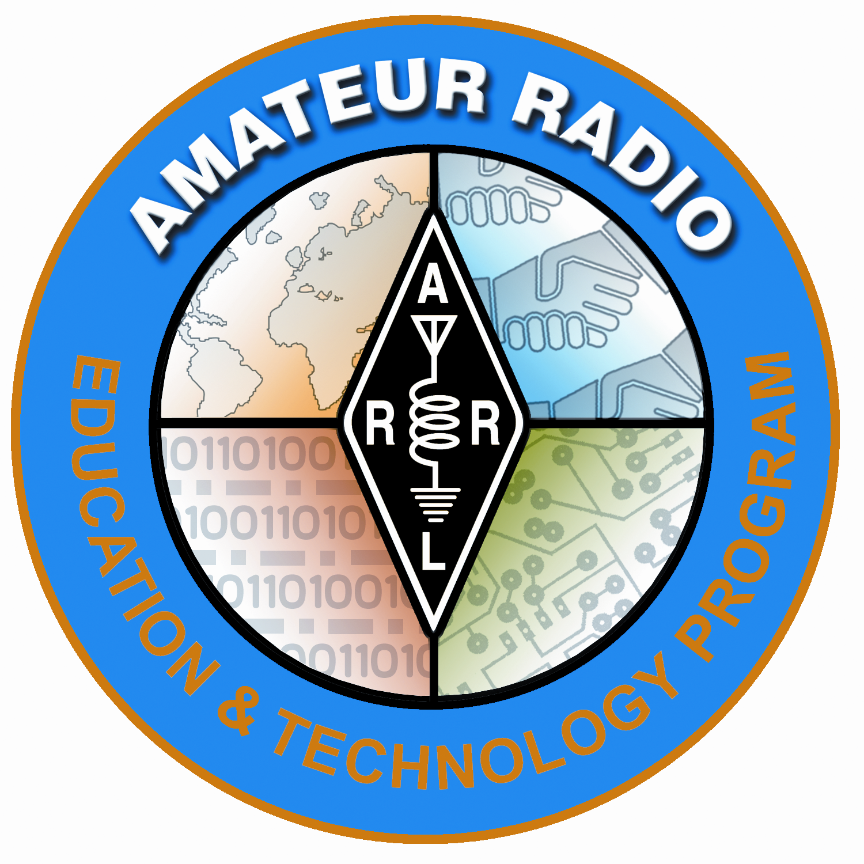
Lesson Plan Prepared for
ARRL Education & Technology Program
Author(s): Nathan McCray | Date: 02/15/2013
Title of Lesson: Resistors | Grade Level: 4 – 12

Core Components

Subject, Content Area or Topic:

Physics, Electronics, Science, Math

National/State Standards: (Assign as needed based on your state standards)

Common Core Standards: (Assign as needed based on your state requirements)

http://www.corestandards.org/

Vocabulary: (Teacher add as needed based on your curriculum and learning requirements)

Learning Objectives (What will the students learn and/or demonstrate?)

The objective of this activity is for the students to explore resistors.

Materials/Resources

- Graphing paper
- Lead pencil
- 9 volt battery
- Leads (Preferably with alligator clips)
- LED (Red would be a cool color to use)
- Volt/Ohm Meter
- Various sized resistors
- Light bulb (Something easily wired with alligator clips)

Safety (if applicable) NA
- Talk about how fuses operate and the cautions surrounding replacing fuses (use the same current rated fuse as the one blown). .

- With no resistance in the circuit, the voltage source will provide the full current available to the circuit. There is essentially no resistance in the VOM probe lines, therefore if the probes are connected directly across the battery poles, the full current in the battery will flow through the VOM, and probably blow the fuses.
- Emphasize that during the current measurement exercises, they must be careful to ensure that the suggested resistance is in the circuit and that the VOM probes are placed as illustrated or shown.
- Have the class practice probe placement before connecting to power.

Prerequisite Understanding:
- Conductors and Insulators
- Basic Electricity
- Current
- Ohm’s Law

Process Components
Anticipatory Set:
(“The Hook” -- something to excite the student about the subject matter)

This lesson acts as an anticipatory set that you would use before getting into a deeper understanding of resistors. However, a nice way to “hook” your students is by making a graphite pencil resistor. First, have your students wire a simple circuit with a 9V battery connected to a light (a switch is optional.) Have your students (I like to work in groups with this kind of activity) note the brightness of the light bulb. Next, insert a graphite pencil (#2 should work, just not as well as an artist’s graphite pencil.) in the circuit ensuring both ends are sharpened. Have your student’s note the brightness of the light after the pencil is inserted in the circuit. Brainstorm why the pencil works in an electric circuit.

Instructional Input or Procedure (Input, modeling, and checking for understanding)

*Note, you may demo this first, then have your students do this. Or, if you feel comfortable, have your students conduct the experiment with you at the same time. .

Directions:

- Fill in about a two inch area of single blocks on your graph paper with the led pencil. Apply it as heavy as you can! You are making a graphite resistor!
- Place one lead of your VOM on one side of the graphite resistor you made and the other lead on the other side. You should get a reading of about .5 Ohms.
- Move the leads closer together and you will see the meter change. You now have the equivalent of a variable resistor.
- Next, place the wire lead (with alligator clip) to the positive side of the 9V battery and the other end to the positive side of the red LED.
- Place the other wire on the negative side of the battery and then the other end to one side of the graphite resistor.
- Next, place the negative lead of the red LED to the graphite resistor.
- Move the wire that is on one end of the graphite resistor towards the red LED. You should see the LED get brighter as you move the wire closer to the LED and lighter as you move away (You made a dimmer!)

Questions:

- What might happen if you touched the wire lead directly to the red LED?

Talk with your students about what they are observing.

Guided Practice

- Have your students measure the resistance of various resistors
- Have your students make measurement with different settings on the V.O.M. It is wise to always start at higher settings. Talk to your students about how the decimal moves when they change settings.
- Have a discussion on decimals and place values (This would be a great science lesson to do at the same time you are teaching place values!)

Independent Practice

Suggest some measurements your students might make, but leave the majority of the measurement techniques up to them.

Some suggestions:
- Probes across individual fingers. 1.8 meg
- Probes held between thumb and finger, one in each hand. 1.4 meg
- Probes from the skin on the ankle and skin on hand. Off scale
- Dry skin versus moist skin. Dry 1 meg, moist 96k
- Lightly touching ht probes compared to a firmer grasp on the probes. Light 1 meg, firm 300k

The lesson here is that body contact with the probes during measurements can influence the ohmmeter reading and should be avoided, particularly when measuring high values of resistance.

Assessment/Closure

Assessment (Pre, post etc…)

What is resistance?

What is the purpose of a resistor in a circuit? Is there more than one purpose?

If you take a resistor out of its circuit and then apply power to that circuit, what may happen?

Enrichment:
Verify Ohms Law:
Measured Battery Voltage:_______
Measured Current:_____________
Measured Resistance: __________

E = I * R
_______=________*________

Resources/References

http://www.arrl.org/files/file/ETP/Basic%20Electronics%20Course.pdf

ARRL Handbook Pages 2.5 – 2.6

Understanding Basic Electronics pages 7.6 – 7.8

http://www.youtube.com/watch?v=VPVoY1QROMg

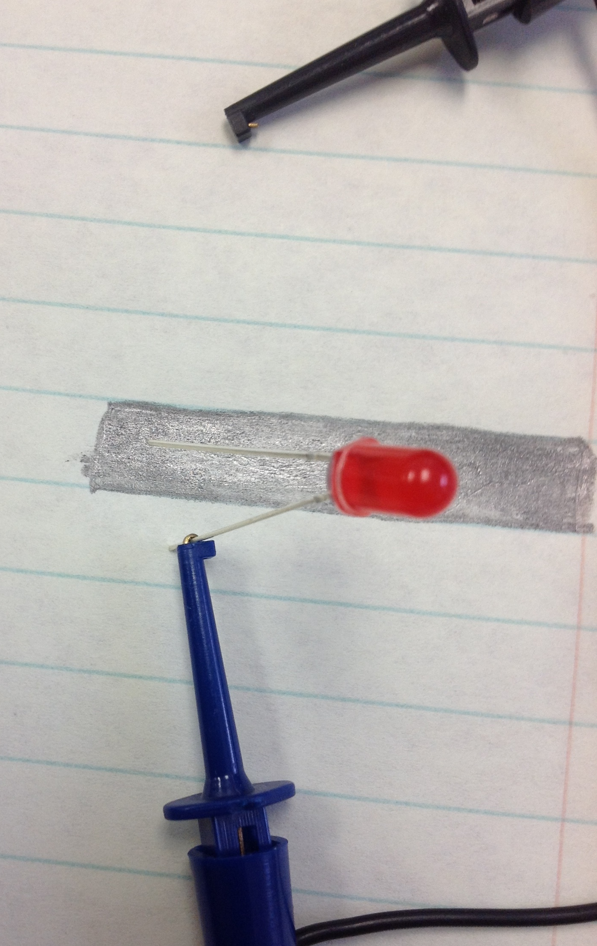
Positive (+) lead to long Lead on LED

*Every lesson is different so you may not have to fill in all areas.

Notes:

